**DAILY ONLINE ACTIVITIES SUMMARY**

|  |  |  |  |  |  |  |  |
| --- | --- | --- | --- | --- | --- | --- | --- |
| **Date:** | | **26/05/2020** | | | | | |
| **Name of the Faculty** | | **Shruthi Shetty J** | | | | | |
| **No. of Students Allotted for monitoring** | | | | | **26** | | |
| **Progress** | | | | | **Good** | | |
| **Whether collected report from all the allotted students** | | | | | **25** | | |
| **Online Test Summary** | | | | | | | |
| **Subject** | **Operation Research test** | | | | | | |
| **Semester** | **6** | | | **Duration** | | **1 HOUR** | |
| **No. of students Taken** | | | **107** | **Passing %** | | **95.3** | |
| **Certification Course Summary** | | | | | | | |
| **Course** | | **FDP on Networks and Security organized by NMAMIT,NITTE and FDP on AI by AIET and a webinar on Accelerating Industry 4.O, by ICT academy.** | | | | | |
| **Certificate Provider** | | **NMAMIT,AIET, ICT Academy** | | | **Duration** | |  |
| **Coding Challenges** | | | | | | | |
| **Problem Statement:** C:\Users\Pc\Downloads\Code1.PNG | | | | | | | |
| **Status:** | | | | | | | |
| **Uploaded the report in Github** | | | | | **Yes** | | |
| **If yes Repository name** | | | | | <https://github.com/ShruthiShettyJ/daily-report> | | |
| **Uploaded the report in slack** | | | | | **Yes** | | |

Online Test Details: (Attach the snapshot and briefly write the report for the same)

Certification Course Details: (Attach the snapshot and briefly write the report for the same)

Coding Challenges Details: (Attach the snapshot and briefly write the report for the same)

**Certification Course Summary:**

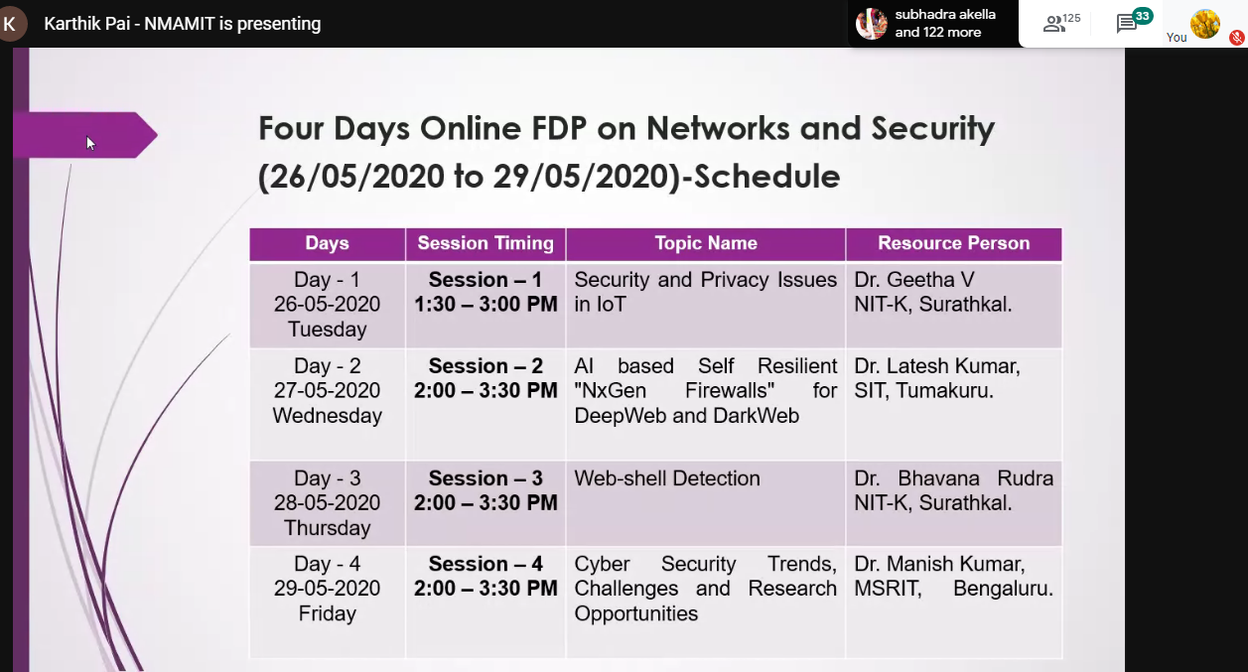

**Sample Students Report:**

